Assignment Day 5

1. Add a 10GB disk to the CentOS.

* Go to VMware (make sure your centos is already installed) Centos edit VM settings.
* Add hard Disk 10 GB.
* Finish.
* Power ON CentOS.
* Login as a Root User.
* Open terminal & type lsblk command.

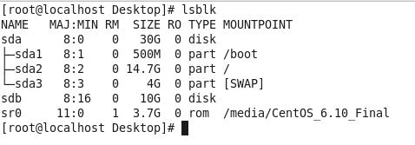

2. Create 2 Partitions 4GB and 6GB of Space respectively.

* Type fdisk -l command to show the disk properties.
* Type fdisk /dev/sdb.

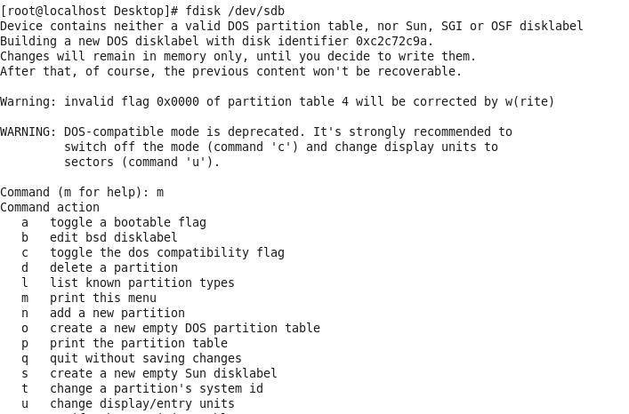

* Command ‘n’ to add a new partition.

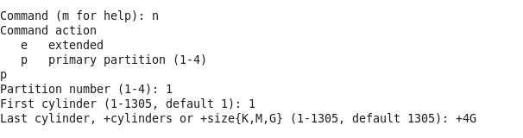

* 4GB partition created.
* Add another 6GB partition same as it is.

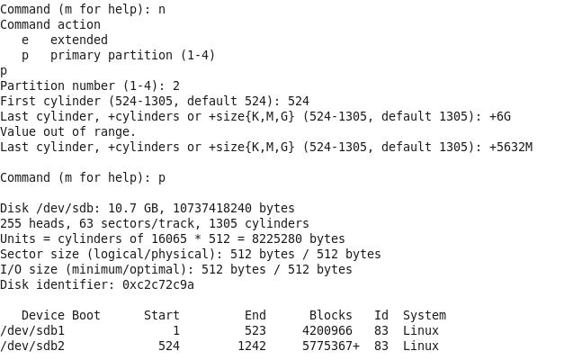

* 4GB & 6GB partition created.

3. Format 4GB with xfs and 6GB with ext4 file system.

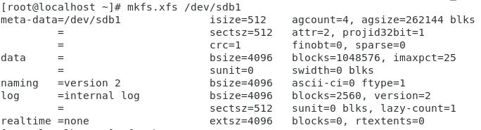

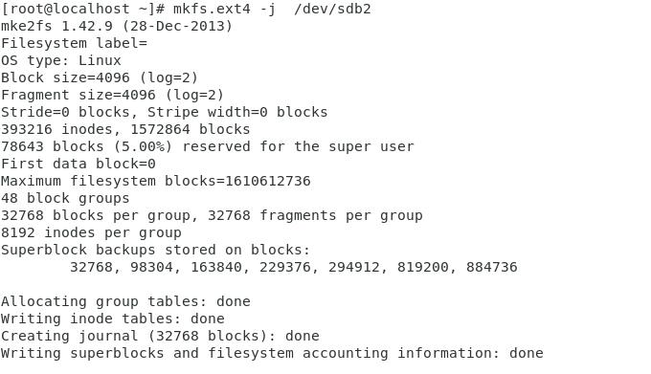

4. Mount 4GB and 6GB in /data and /music directory respectively.

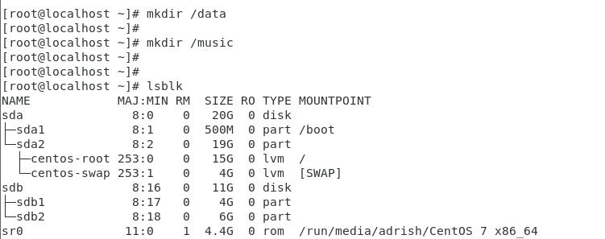

/data and /music created.

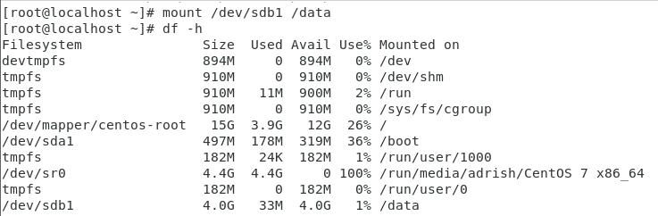

/dev/sdb1 4GB mounted on /data dir.

After Type ‘mount’ command.

C:\Users\USER\Desktop\ice_screenshot_20201206-022045.jpeg

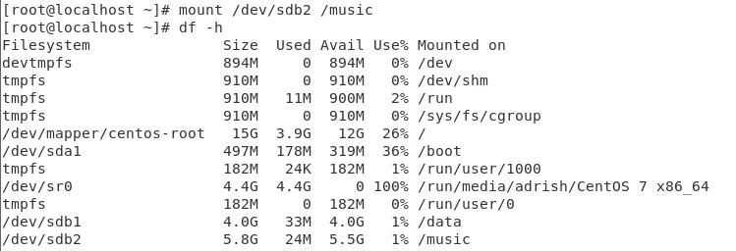

/dev/sdb2 6GB mounted on /music dir.

C:\Users\USER\Desktop\ice_screenshot_20201206-022834.jpeg

5. Create one file of 1GB in each of the mount point created above.

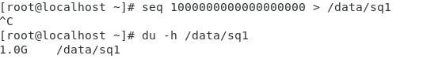

6. Verify the disk Consumption and disk space free in the mounted partitions.

